INSTALLING JENKINS IN LINUX OR UBUNTU AND CRATING A FREESTYLE JOB IN NGINX PROJECT

Installing Java 17

sudo apt install -y openjdk-17-jdk

sudo update-alternatives --config java

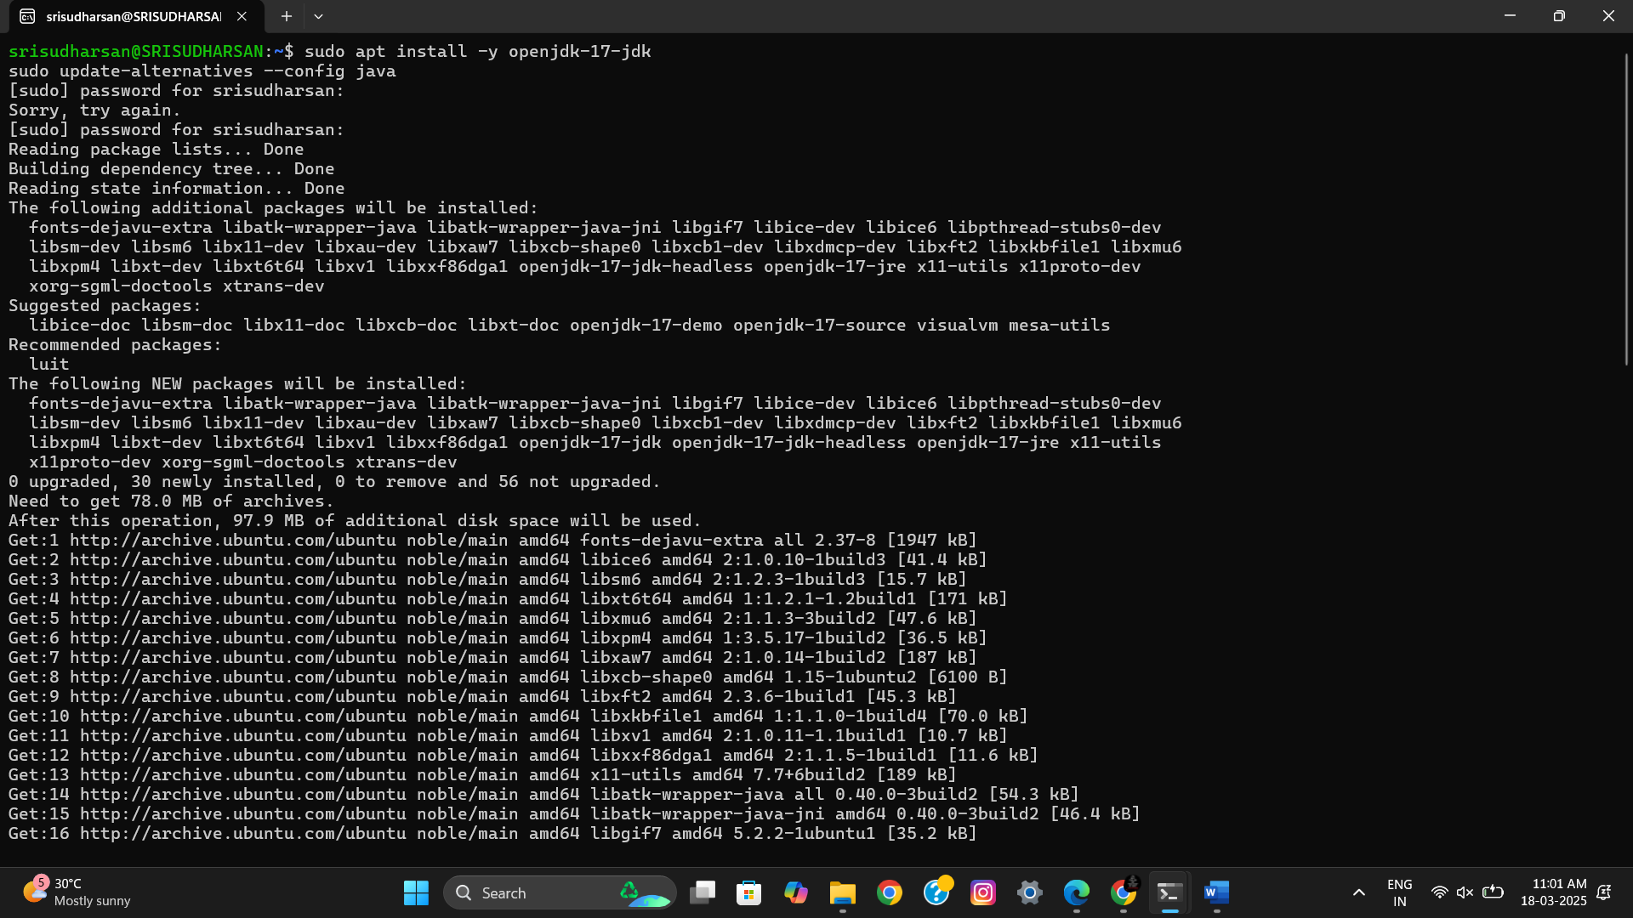

* After this you'll be prompted to select a java version select the index with java-17

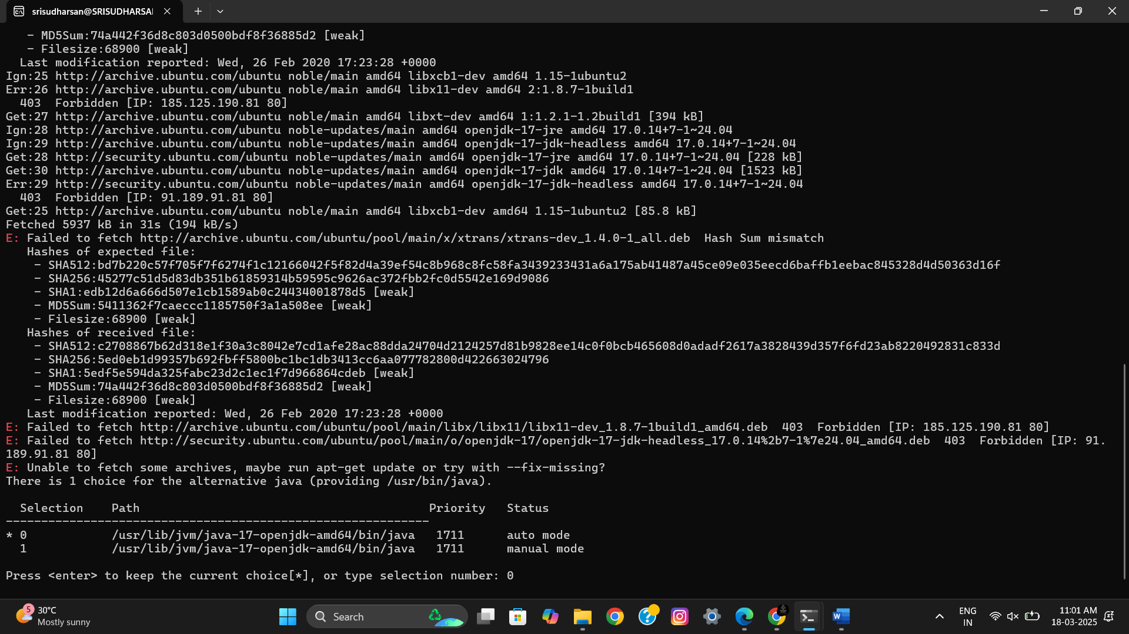

Installing Jenkins

sudo wget -O /usr/share/keyrings/jenkins-keyring.asc \

https://pkg.jenkins.io/debian-stable/jenkins.io-2023.key

echo "deb [signed-by=/usr/share/keyrings/jenkins-keyring.asc]" \

https://pkg.jenkins.io/debian-stable binary/ | sudo tee \

/etc/apt/sources.list.d/jenkins.list > /dev/null

sudo apt-get update

sudo apt-get install Jenkins

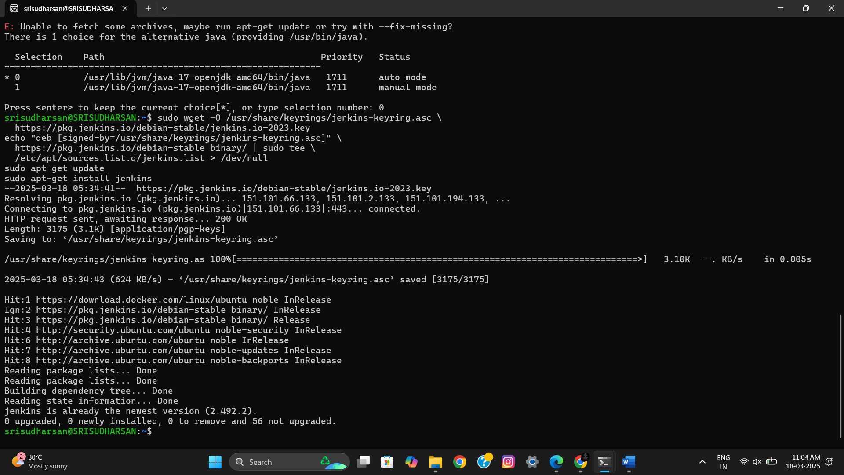

Starting Jenkins

code

sudo systemctl status jenkins

sudo systemctl enable jenkins

sudo systemctl start jenkins

sudo systemctl status Jenkins

* Copy the password provided in this step

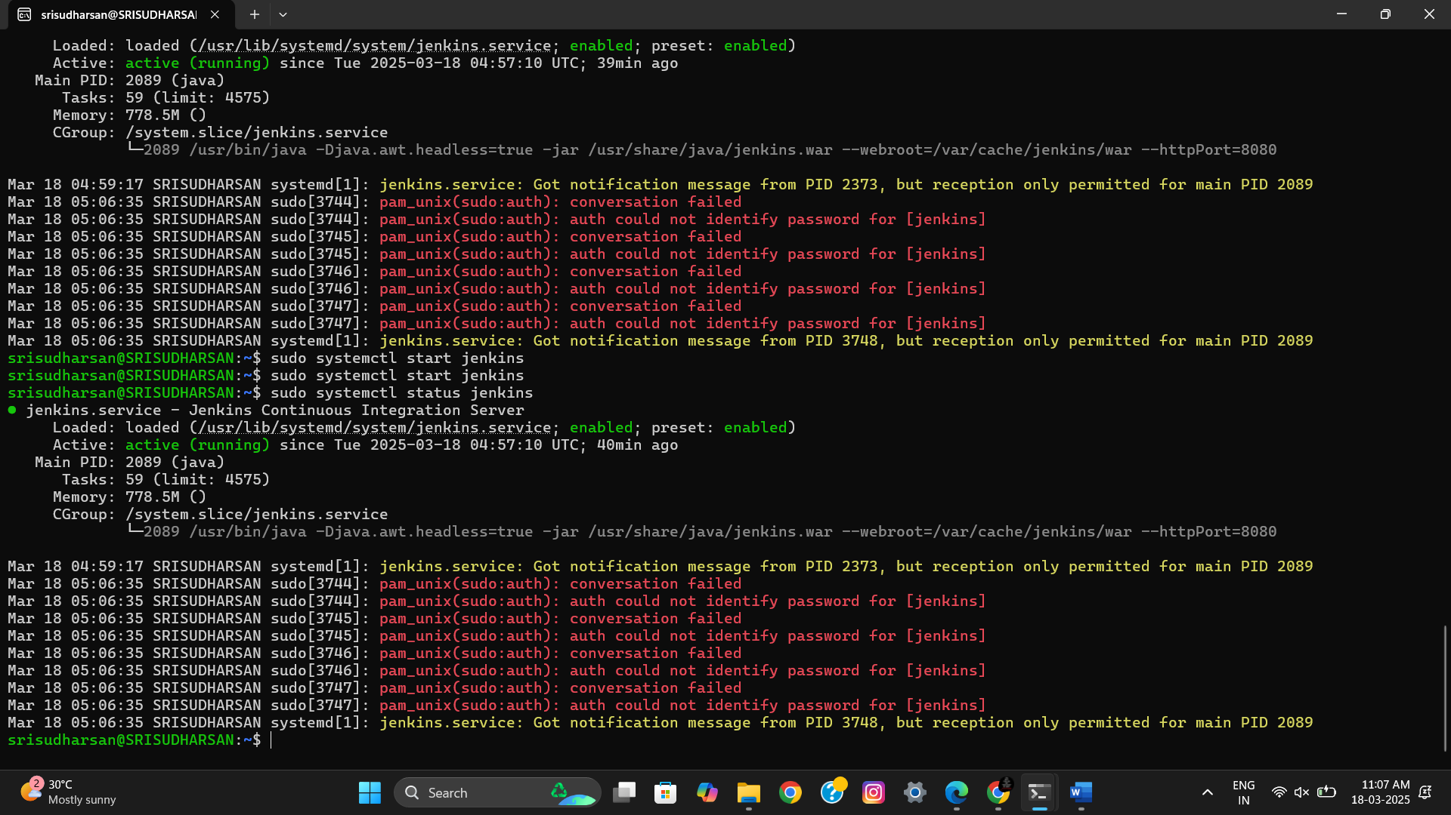

Jenkins Initial Setup

* Open a browser and go to localhost:8080 and paste in the password

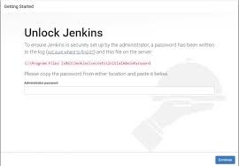

Code: To find the password  
sudo cat /var/lib/jenkins/secrets/initialAdminPassword

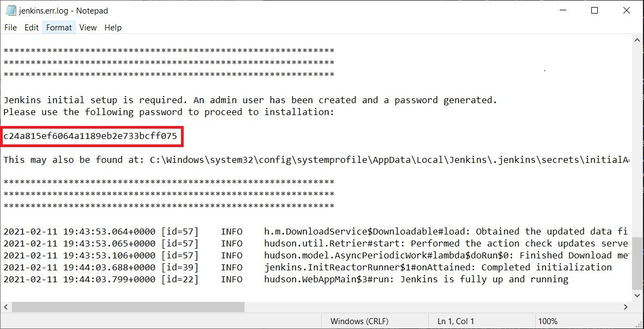

* Now you see the below and click on install suggested plugin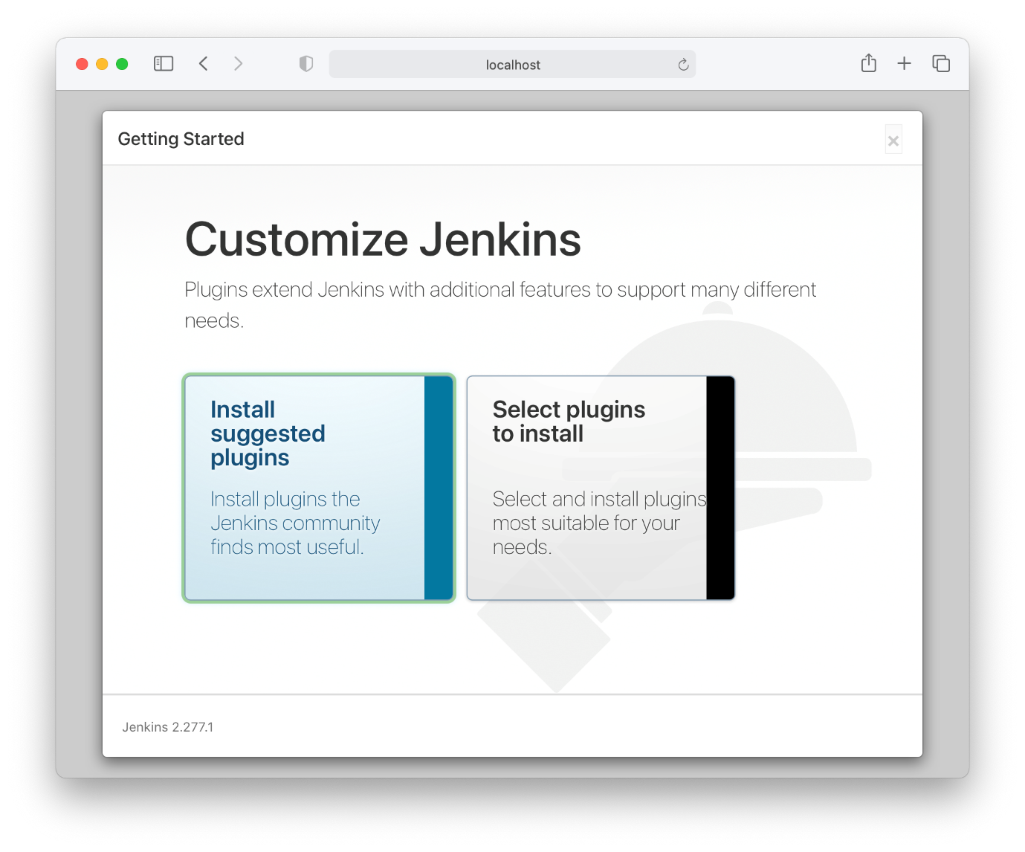
* The The plugins will eb installed one by one and you'll be redirected to the next page click Start Jenkins

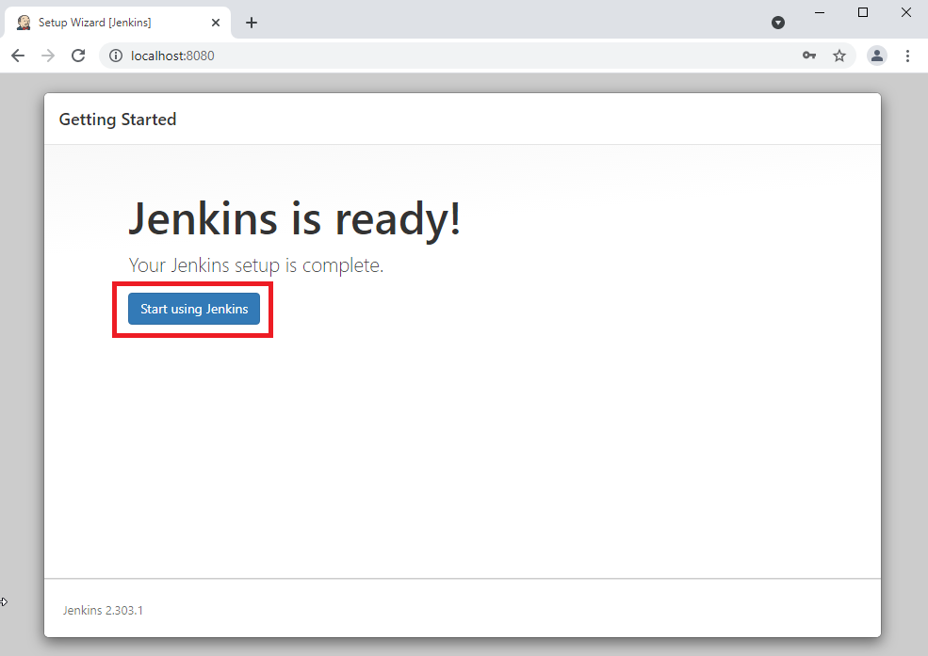

* Remember this user id and password. This will overwrite the Initial Password generated, and will be required to login everytime you restart Jenkins.

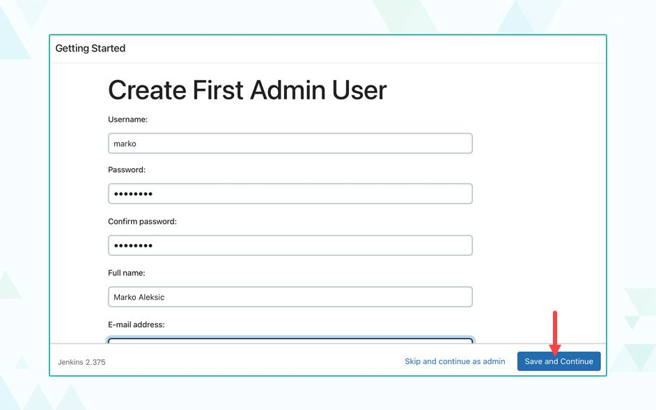

Setting up a Nginx freestyle project in Jenkins

* In Jenkins home page click on create a job
* Enter a project name
* Select Freestyle Project
* Click Ok

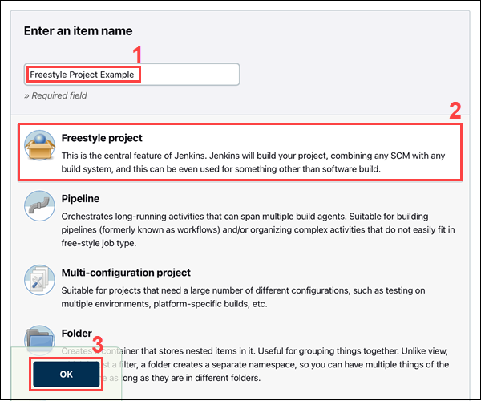

* Paste the below in the build steps
* Code:

sudo apt update -y

sudo apt install -y nginx

sudo systemctl enable nginx.service

sudo systemctl start nginx

systemctl status nginx

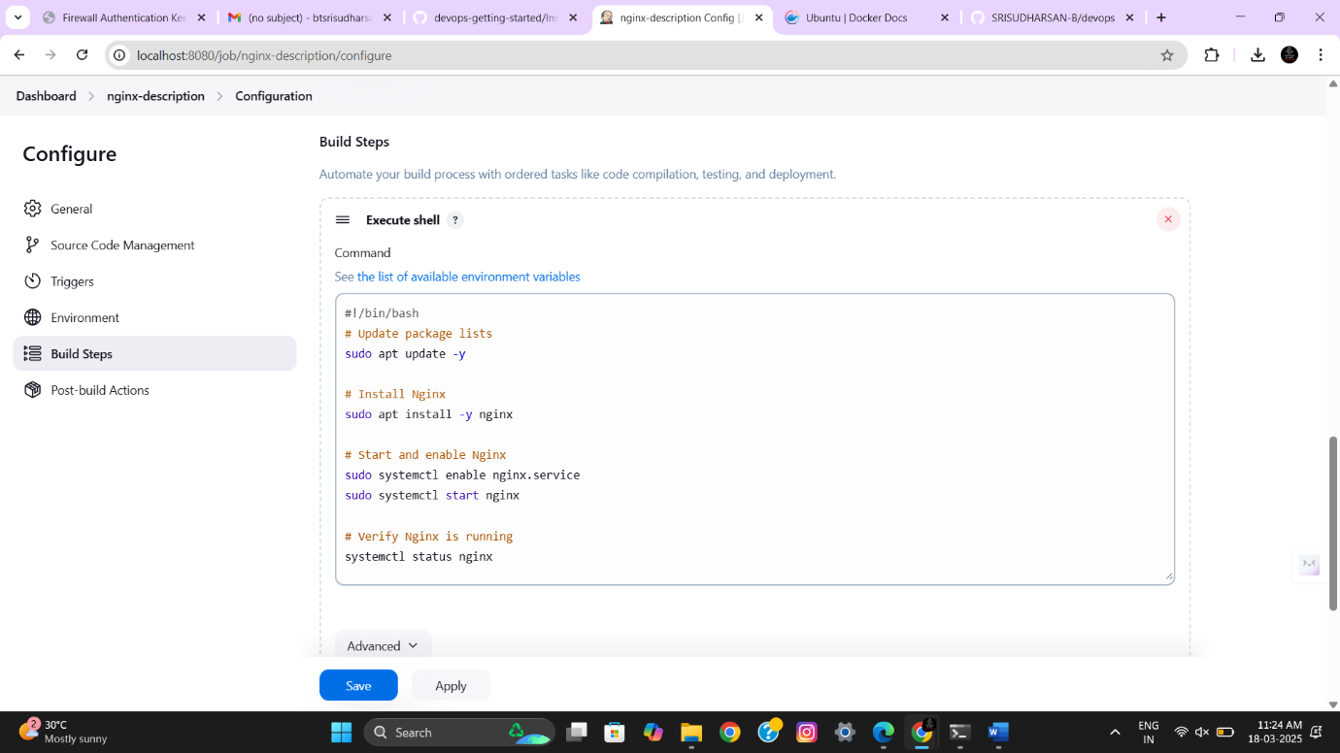

* And finally save the project:

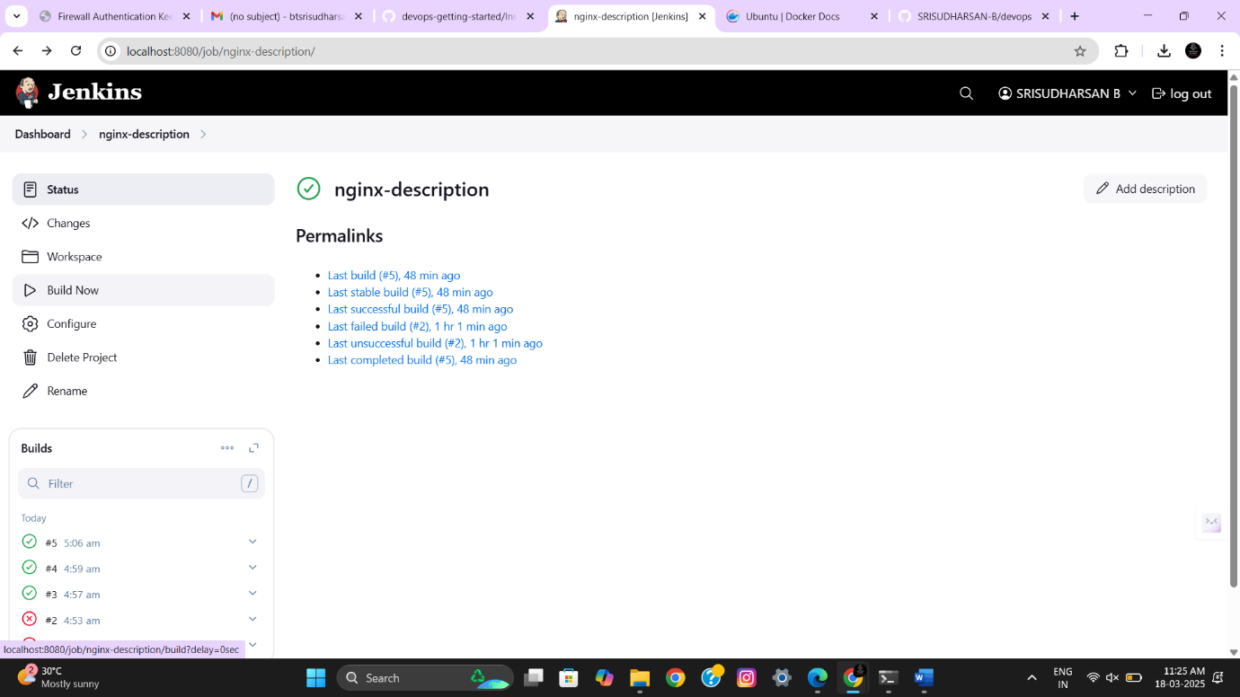

* Your first Nginx project using Jenkins is successfully deployed!